Taylor Cowley

EE 220 May 25 2016

Lab 09 Counters State Machine Design

**Programmable timer calculations for 10Hz signal**

50MHz / 10Hz = 5000000 (number to give timer)

**SR Latch Verilog Module**

module latch(go, start, stop);

output reg go;

input start, stop;

always@(go, start, stop)

begin

if(start)

go = 1;

else

if(stop)

go = 0;

else

go = go;

end

endmodule

**SR Latch TCL file**

isim force add start 0 -time 0 -value 1 -time 20ns -value 0 -time 30ns

isim force add stop 0 -time 0 -value 1 -time 10ns -value 0 -time 15ns -value 1 -time 24ns -value 0 -time 28ns -value 1 -time 50ns

run 60ns

**SR Latch Simulation**

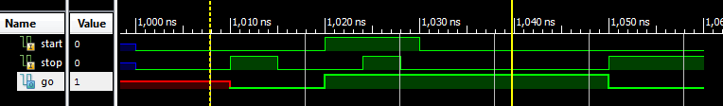

**MOD6 Verilog Module**

module count6(out, incr, reset, clk);

output reg[2:0] out;

input incr, reset, clk;

always@(posedge clk)

begin

if(reset)

out = 0;

else if(incr)

if(out == 3'd5)

out = 0;

else

out = out + 1;

else

out = out;

end

endmodule

**MOD6 TCL file**

isim force add clk 0 -time 0 -value 1 -time 10ns -repeat 20ns

isim force add incr 0 -time 0 -value 1 -time 50ns -value 0 -time 580ns

isim force add reset 1 -time 0 -value 0 -time 25ns

run 600ns

**MOD6 Simulation Waveform**

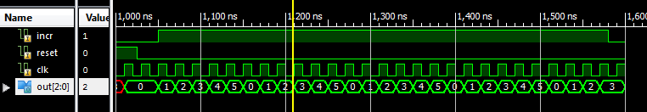

**MOD10 Verilog module**

module count10(out, incr, reset, clk);

output reg[3:0] out;

input incr, reset, clk;

always@(posedge clk)

begin

if(reset)

out = 0;

else if(incr)

if(out == 4'd9)

out = 0;

else

out = out + 1;

else

out = out;

end

endmodule

**MOD10 TCL file**

isim force add clk 0 -time 0 -value 1 -time 10ns -repeat 20ns

isim force add incr 0 -time 0 -value 1 -time 50ns -value 0 -time 580ns

isim force add reset 1 -time 0 -value 0 -time 25ns

run 600ns

**MOD10 simulation waveform**

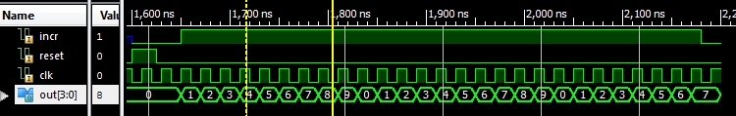

**Counter block Verilog Module**

module counter_block(sec_t, sec_s, ten, min, go, reset, clk);

output[3:0] sec_t, sec_s, min;

output[2:0] ten;

input go, reset, clk;

reg incr_t, incr_s, incr_ten, incr_min;

count10 tenths(sec_t, incr_t, reset, clk);

count10 seconds(sec_s,incr_s, reset, clk);

count6 tens( ten, incr_ten,reset, clk);

count10 minutes(min,incr_min,reset, clk);

always@(sec_t, sec_s, ten, min, go)

begin

if(go)

begin

incr_t = 1;

if(sec_t == 9)

begin

incr_s = 1;

if(sec_s == 9)

begin

incr_ten = 1;

if(ten == 5)

begin

incr_min = 1;

end

else

begin

incr_min = 0;

end

end

else

begin

incr_ten = 0;

incr_min = 0;

end

end

else

begin

incr_s = 0;

incr_ten = 0;

incr_min = 0;

end

end

else

begin

incr_t = 0;

incr_s = 0;

incr_ten = 0;

incr_min = 0;

end

end

endmodule

**Counter block TCL File**

isim force add clk 0 -time 0 -value 1 -time 10ns -repeat 20ns

isim force add reset 1 -time 0 -value 0 -time 25ns

isim force add go 0 -time 0 -value 1 -time 30ns

run 6ms

**Counter block Simulation waveform**

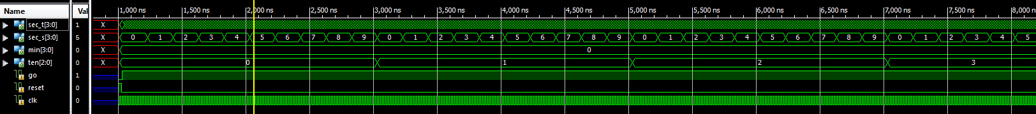

**TestBench Verilog Module**

module stopwatch(seg, an, dp, btn, clk);

output[6:0] seg;

output[3:0] an;

output dp;

input [3:0] btn;

input clk;

wire reset;

wire reset_timer;

wire pulse;

wire start, stop;

prog_timer timer(clk, reset, 1, 24'd5000000, , pulse, );

wire[3:0] secs, tenths, mins;

wire[2:0] tens;

wire go;

counter_block counter(tenths, secs, tens, mins, go, reset_timer, pulse);

assign start = btn[3];

assign stop = btn[2];

assign reset = btn[1];

assign reset_timer = btn[0];

latch l(go, start, stop);

wire[15:0] data;

assign data[15:12] = mins; // mins

assign data[11:8] = {1'b0, tens}; // tens of seconds

assign data[7:4] = secs; // seconds

assign data[3:0] = tenths; // tenths of seconds

seg4x7 seg_controller(seg, an, dp, 4'b1010, data, clk, reset,);

endmodule

**TestBench UCF File**

## clock pin for Nexys 2 Board

NET "clk" LOC = "B8";

## Buttons

NET "btn<0>" LOC = "B18";

NET "btn<1>" LOC = "D18";

NET "btn<2>" LOC = "E18";

NET "btn<2>" CLOCK_DEDICATED_ROUTE = FALSE;

NET "btn<3>" LOC = "H13";

## 7 segment display

NET "seg<0>" LOC = "L18";

NET "seg<1>" LOC = "F18";

NET "seg<2>" LOC = "D17";

NET "seg<3>" LOC = "D16";

NET "seg<4>" LOC = "G14";

NET "seg<5>" LOC = "J17";

NET "seg<6>" LOC = "H14";

NET "dp" LOC = "C17";

NET "an<0>" LOC = "F17";

NET "an<1>" LOC = "H17";

NET "an<2>" LOC = "C18";

NET "an<3>" LOC = "F15";

**Anomalies**

This lab was much easier than the last lab. I really had no problems. There is a weird thing though- when I load the FPGA, it starts ticking the stopwatch immediately. I tried assigning an initial value to the go signal, but the synthesizer doesn’t support that. I don’t know why it does this.